The Effect of height on the diameter of blood splatter evidence at a crime scene

The purpose of this lab is to explore the relationship between the diameter of a blood splatter drop to the height from which it fell. Blood spatter is used at crime scenes to help investigators to determine the cause of death and help to identify the weapon used. Blood spatter can also show how a victim was killed, maybe slowly or instantly. If they fell, or if the blood was dripping.

Hypothesis
If I drop blood from an increasing height, then the blood drop diameter will get smaller.

Materials
- Simulated Blood
- Pipette
- Meter stick (for measuring)
- White Paper
- Paper Towels

Procedure
- Place your paper on the floor
- Put two meter sticks on top of each other
- Fill pipette with simulated blood
- Find specified height and squeeze pipette
- Measure diameter of blood
- Record data

Data Table

Height (cm) | 60 | 80 | 90 | 100 | 110 | 120 | 130 | 140 | 150 | 160
Diameter  (mm) | 11 | 14 | 15 | 17 | 15 | 18 | 17 | 17 | 20 | 18

Data Analysis
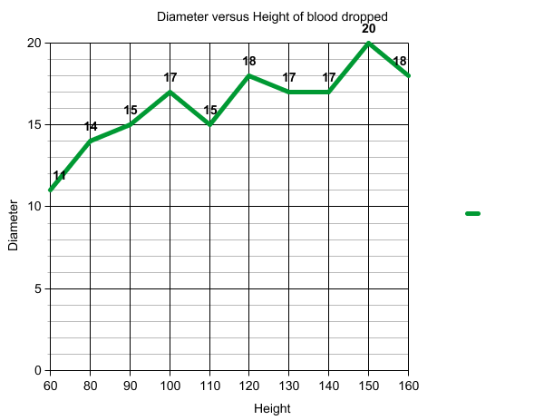

Conclusion:
I believe the hypothesis was correct. The higher I went up the more my diameter would extend for some of the samples collected. I found out that using the diameter you could also find the height of where they were from.
- To make sure that nothing went wrong during it my partner and I made sure that the yard sticks were stable and then making sure nothing was wrong with the blood dropped it from the designated height.
- If there was a murder committed there would be different types of patterns. Let’s say the victim was being dragged, the blood would be trails of blood. If the victim was shot there would be splatter marks over the crime scene. I believe Anna was bleeding from the head or somewhere near, but I do not know how it happened. It could of been from a violent act of aggression or a bloody nose.
- Using the information gathered these scientists can figure out what are some possible scenarios regarding how Anna died, and then the investigators can use order of elimination to find out what happened, but this is a huge step in finding out how.

